Windows

All

Disable Hibernate
(also delete file “hiberfil.sys”)

powercfg -h off
(run “powercfg -h on” to turn it on)

Find running Services
Ex: net start | find /I "mySQL"

Find running Processes
(by port number)
Ex: netstat -a -o | find /I "80”

Remote desktop
Switch from/to Full screen mode
Ctr + Alt + Break

Copy / Paste
Restart “rdpclip.exe” to make it work

Kill Process
Taskkill /F /PID <Process_Id>

Create virtual disks (subst)
Create: SUBST [drive1: [drive2:]path]
Ex:
subst E: d:\Softwares
Delete: SUBST drive1: /D
Ex:
Subst E: /D

Custom label
A custom label can^{[citation needed]} be assigned to a drive letter created in this way by way of a registry key, which can be created by renaming (select "rename" from the drive letter context menu or press F2 ) the SUBST drive in Windows Explorer/ My Computer.
HKEY_LOCAL_MACHINE\SOFTWARE\Microsoft\Windows\CurrentVersion\Explorer\DriveIcons\M\DefaultLabel\
(DefaultValue) = Your Drive Label
"M" represents the drive letter to assign a custom label to.
However, labels created for SUBST drives in this manner are overridden by the label of the host drive/partition: the custom labels are only used if the host drive has no label. One may then:
- Delete the host's drive label;
- Create the proper registry keys for the SUBST drive letter;
- Create the proper registry keys for the host drive letter (optional, works around the host drive label override caveat);
- Re-create the SUBST drive to see label changes applied

Persisting across reboots
Drive letters mapped in this way are not available during system startup for services nor do they persist across a reboot. However with a registry modification it is possible to assign a path to a drive letter during startup so it is available to system services and persists across a reboot.
Create a new registry entry "String Value" in the following key: HKEY_LOCAL_MACHINE\SYSTEM\CurrentControlSet\Control\Session Manager\DOS Devices
The name should be "X:" where X is the drive letter.
The value should be the path in the form: \??\C:\some\directory
or in form: \DosDevices\C:\some\directory
or in form: \Device\Mup\127.0.0.1\C$\some\directory
There are tools available to make the necessary changes for you.

The relative to this thematic registry key is HKEY_LOCAL_MACHINE\SYSTEM\MountedDevices It defines mapping of drive letters into particular hard disk partitions, similar to /etc/fstab on a Unix system. It also can be edited manually, but only at that time while that particular installed Window operation system is "inactive". So that, for example, if you currently boot from "D:\Windows" then you can edit the HKEY_LOCAL_MACHINE\SYSTEM\MountedDevices key of Windows that is installed in a "C:\Windows" folder, for an instance by doing the following actions:

1.run command: reg load hklm\$system C:\WINDOWS\system32\config\system
2.run command: regedit.exe
3.edit registry key HKEY_LOCAL_MACHINE\$system\MountedDevices
(that represents the HKEY_LOCAL_MACHINE\SYSTEM\MountedDevices registry key of the Windows instance that is installed in C:\WINDOWS)
4.close regedit.exe
5.run command: reg unload hklm\$system (to complete the editing procedure)
Limitations
Not all Windows processes are able to use a drive letter created in this way.[2]
Since (at least) Microsoft Windows XP SP2 Autorun.inf files present in the new drive letter are ignored; thus, AutoRun/AutoPlay does not work on drive letters created in this way. In addition, assigning a custom icon or label to the drive letter created this way via Autorun.inf does not work. A custom label assigned to the drive letter created with Subst only appears if the source drive/volume does not have a volume label set (check and set with the label command).

No need Ctrl + Alt + Del
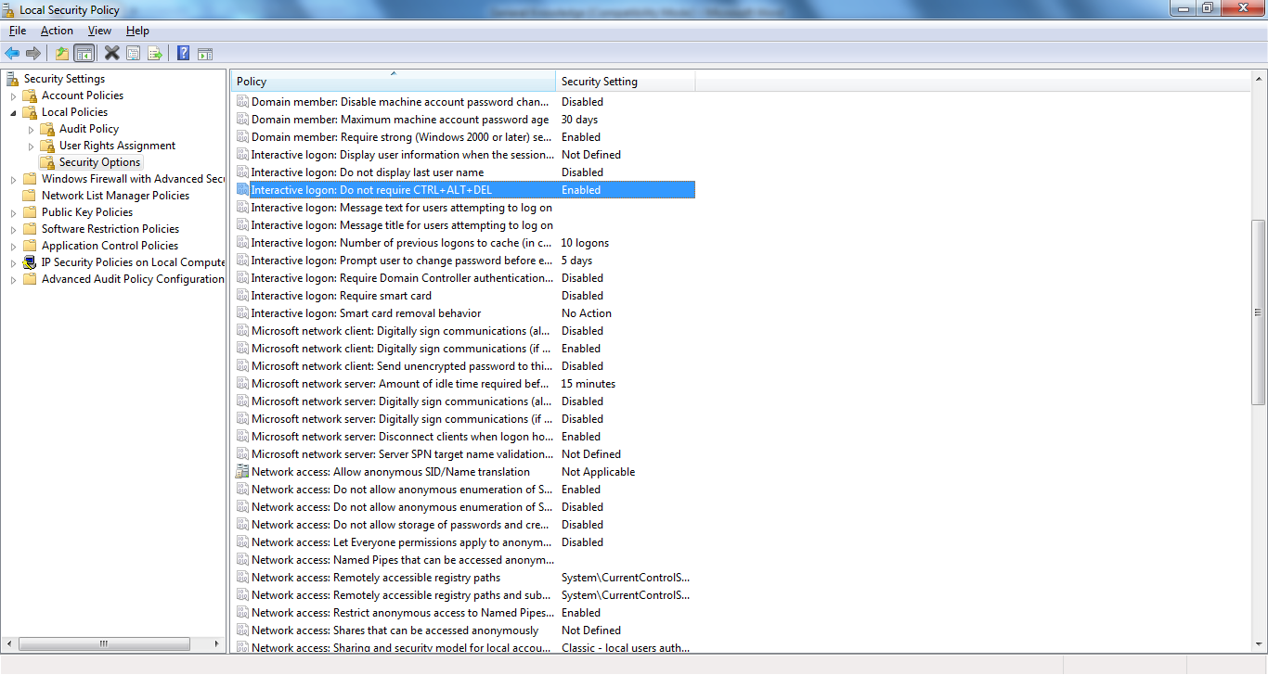

Windows XP

Control Panel (.cpl) Files
Table I. Some Control Panel Applet Files
File | Function | Tabs (number in parentheses is index n discussed below)
access.cpl | Accessibility controls | Keyboard(1), Sound(2), Display(3), Mouse(4), General(5)
appwiz.cpl | Add/Remove Programs
desk.cpl | Display properties | Themes(5), Desktop(0), Screen Saver(1), Appearance (2), Settings(3)
hdwwiz.cpl | Add hardware
inetcpl.cpl | Configure Internet Explorer and Internet properties | General(0), Security(1), Privacy(2), Content(3), Connections(4), Programs(5), Advanced(6)
intl.cpl | Regional settings | Regional Options(1), Languages(2), Advanced(3)
joy.cpl | Game controllers
main.cpl | Mouse properties and settings | Buttons(0), Pointers(1), Pointer Options(2), Wheel(3), Hardware(4)
main.cpl,@1 | Keyboard properties | Speed(0), Hardware (1)
mmsys.cpl | Sounds and Audio | Volume(0), Sounds(1), Audio(2), Voice(3), Hardware(4)
ncpa.cpl | Network properties
nusrmgr.cpl | User accounts
powercfg.cpl | Power configuration | Power Schemes, Advanced, Hibernate, UPS (Tabs not indexed)
sysdm.cpl | System properties | General(0), Computer Name(1), Hardware(2), Advanced(3), System Restore(4), Automatic Updates(5), Remote (6)
telephon.cpl | Phone and modem options | Dialing Rules(0), Modems(1), Advanced(2)
timedate.cpl | Date and time properties | Date & Time(0), Time Zone(1), Internet Time (no index)
Ex: control main.cpl,@0, 2

Truy cap file chia se ko yeu cai user phai co password
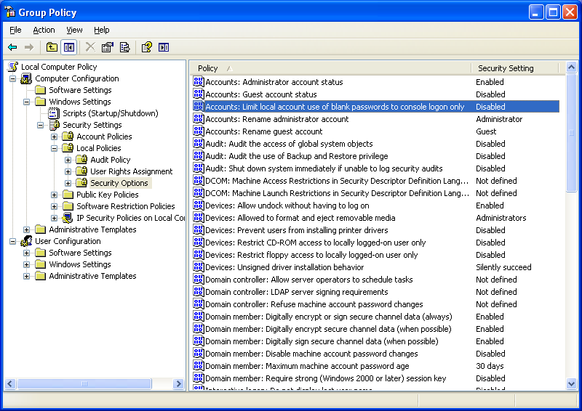

Deny logon locally
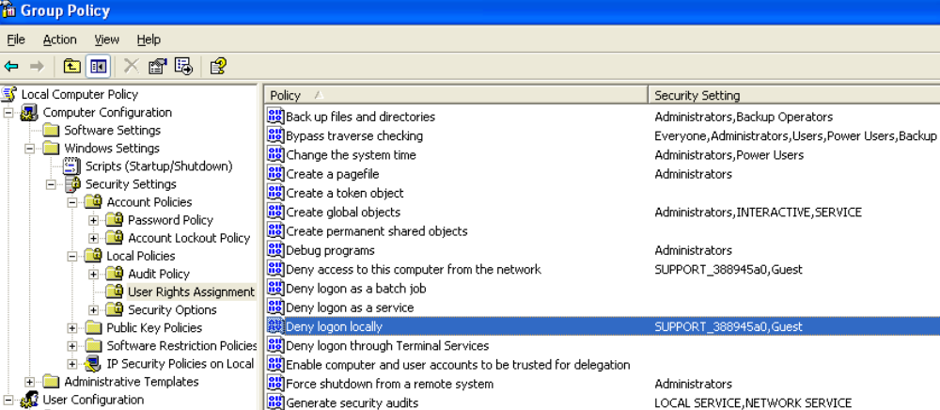

Windows 2k3

Disable the Shutdown Event Tracker

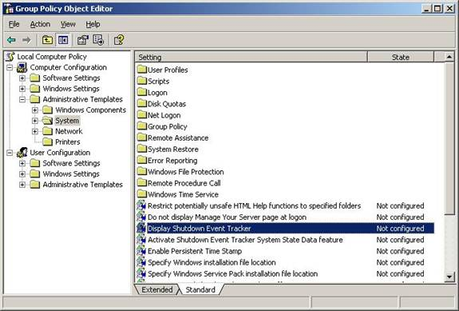
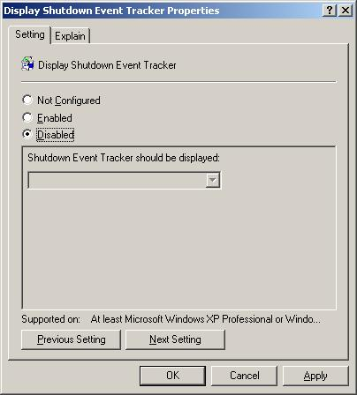

Linux

Clear memory cache
sync
echo 3 > /proc/sys/vm/drop_caches

(Try: sudo echo 3 | sudo tee /proc/sys/vm/drop_caches)

* Note: The first command writes any cache data that hasn't been written to the disk out to the disk. The second command tells the kernel to drop what's cached

* More:
To use /proc/sys/vm/drop_caches, just echo a number to it.

To free pagecache:
echo 1 > /proc/sys/vm/drop_caches

To free dentries and inodes:
echo 2 > /proc/sys/vm/drop_caches

To free pagecache, dentries and inodes:
echo 3 > /proc/sys/vm/drop_caches

As this is a non-destructive operation and dirty objects are not freeable, the user should run "sync" first!

Show Folders' size
du -hs `ls`

Vi (Vim)
(http://www.unix-manuals.com/refs/vi-ref/vi-ref.htm)

Moving cursor
^ Beginning of line
$ End of line
gg Beginning of file
G End of file
ngg (or nG) Go to line n (ex: 3gg → Go to line 3)

Deleting text
x - delete current character
dw - delete current word (after cursor)
dd - delete current line
5dd - delete five lines

d$ - delete to end of line
d0 (or d^) - delete to beginning of line

d1G - delete to beginning of file
dG Delete to end of file

Zip / Unzip

Gzip / Gunzip
Ex:

gzip -c file1.txt > /tmp/foo.gz

gunzip -c foo.gz > /tmp/file1.txt

Tar command
To create an archive using tar, use a command like this, which bundles all the files in the current directory that end with .doc into the alldocs.tar file:

tar cvf alldocs.tar *.doc

Here's a second example, which creates a tar file named panda.tar containing all the files from the panda directory (and any of its subdirectories):

tar cvf panda.tar panda/

To automatically compress the tar file as it is being created, add the z flag, like this:

tar cvzf alldocs.tar.gz *.doc

Wget (Download files)
wget [option]... [URL]...

Ex:
wget http://maven.pyramid-consulting.com/pyco-repo/org/osmoz/osmoz-base/2.1.10-RELEASE/osmoz-base-2.1.10-RELEASE.jar

Eclipse

Projects paths setting in workspace
\.metadata\.plugins\org.eclipse.jdt.ui\dialog_settings.xml
\.metadata\.plugins\org.eclipse.core.resources\.projects\<project_name>\.location

Show Selected Element Only
Window->Customize Perspective->Commands tab (or “Command Groups Availability”) ->Editor Presentation
* Or use shortcut: Ctrl + Shift + S

Un-Install Plugins

Eclipse 3.6
Click Help > About and then click Installation Details... to open a dialog showing pages that provide more detail about your installation.
Click the Installed Software tab to see a list of the software items that you have installed into your system.
Select the items that you wish to uninstall.

Project Facets
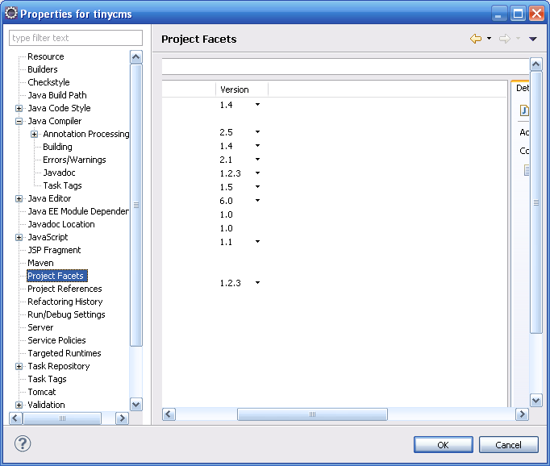

Workspace
Create a shortcut on your desktop with the following target (modified if you're using different directories):
C:\eclipse\eclipse.exe -data C:\workspace -jvmargs -Xms640M -Xmx640

Path of deployed Projects

Tomcat (plug-in)
D:\Workspace\common\.metadata\.plugins\org.eclipse.core.resources\.projects\

Editor Templates
(Java\Editor\Templates)

Logger
private static final org.apache.log4j.Logger logger = org.apache.log4j.Logger.getLogger(${enclosing_type}.class);

Warnings/Errors

Null pointer access
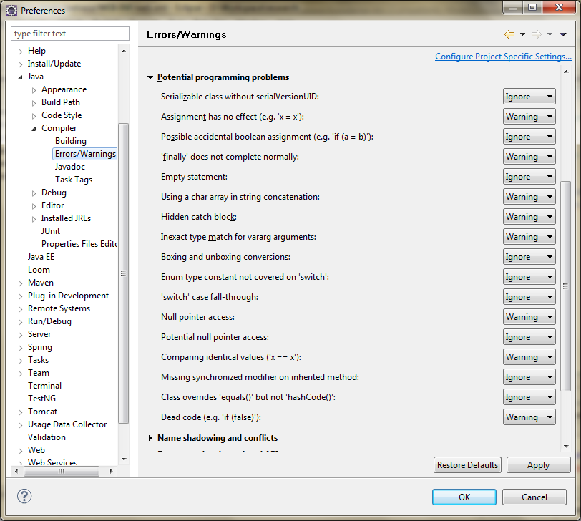

App name in Run/Debug config
<WORKSPACE>\.metadata\.plugins\org.eclipse.debug.ui\launchConfigurationHistory.xml

Tomcat

contextpath
%Tomcat_HOME%\conf\Catalina\localhost

Tomcat Base
Containing these directories:
1. /conf (for server configuration files),
2. /logs (for standard log and output files),
3. /temp (used by the JVM for temporary files [java.io.tmpdir]),
4. /webapps (for the web applications that will be automatically loaded) and
5. /work (temporary working directories for web applications)

Remote debug
Just add the following VM parameters to JAVA_OPTS:
-Xdebug -Xrunjdwp:transport=dt_socket,address=8000,server=y,suspend=n

Execution order of .bat files
startup.bat --> catalina.bat --> setclasspath.bat

Maven

Archetype
Create a quickStart project:
mvn archetype:generate -DarchetypeCatalog= http://tapestry.apache.org
- archetype:create creates a Maven 2 project from an archetype. It uses the behavior of the Archetype Plugin version 1.0-alpha-7.
- archetype:generate ask the user to choose an archetype from the archetype catalog, and retrieves it from the remote repository. Once retrieved, it is processed to create a working Maven project.
- archetype:create-from-project creates an archetype from an existing project.
- archetype:crawl search a repository for archetypes and updates a catalog

Generate project files

Eclipse
mvn eclipse:eclipse

Generate Web project structure
Note: Generate from an empty folder
mvn archetype:create -DgroupId=org.java.demo -DartifactId=module-struts2 -DarchetypeArtifactId=maven-archetype-webapp
Generate web project files
Go to Project folder (cd module-struts2), and issue command below:
mvn eclipse:eclipse -Dwtpversion=2.0

(After that, make sure the nature below is present in .project file:
<nature>org.eclipse.wst.common.project.facet.core.nature</nature>)

Skip compiling test-cases
mvn install -Dmaven.test.skip=true

Skip running test-cases
mvn install -DskipTests

Internet Explorer

Change default View Source editor in IE
Run REGEDIT, follow the following directions to the proper key.
HKEY_LOCAL_MACHINE
|- Software
|-- Microsoft
|--- Internet Explorer
|---- View Source Editor
|----- Editor Name (Default) = C:\windows\notepad.exe
If this doesnt exist (but it should) then create the Key "View Source Editor".
Then create a Key within that named "Editor Name". Modify the "(Default)" value to make it point towards any program on your computer using "D:\Tools\Notepad2\Notepad2.exe" (without the brackets).
[Me] – EditorName.reg
Begin----------------------------------------------------------------
Windows Registry Editor Version 5.00

[HKEY_LOCAL_MACHINE\SOFTWARE\Microsoft\Internet Explorer\View Source Editor\Editor Name]
@="C:\\Program Files\\Windows NT\\Accessories\\wordpad.exe"
End------------------------------------------------------------------

Java

JDBC

Get latest auto-generated key
import java.sql.*;

public class testKeys {
public static void main(String[] args) {
DB db = new DB();
Connection conn=db.dbConnect(
"jdbc:jtds:sqlserver://localhost:1433/tempdb","sa","");
db.performKeys(conn);
}
}

class DB{
public DB() {}

public Connection dbConnect(String db_connect_string,
String db_userid,String db_password){
try{
Class.forName("net.sourceforge.jtds.jdbc.Driver");
Connection conn = DriverManager.getConnection(
db_connect_string, db_userid, db_password);
System.out.println("connected");
return conn;

}
catch (Exception e){
e.printStackTrace();
return null;
}
}

public void performKeys(Connection conn){
String query;
PreparedStatement pstmt;

try{
query = "insert into customer (name,category) "+
"values ('name1','temp')";
pstmt = conn.prepareStatement(query,
Statement.RETURN_GENERATED_KEYS);

pstmt.executeUpdate();
ResultSet keys = pstmt.getGeneratedKeys();
int count = 0;
keys.next();
int key = keys.getInt(1);
query ="update customer set age =? where id =?";
pstmt = conn.prepareStatement(query);
pstmt.setFloat(1, 26);
pstmt.setInt(2, key);
pstmt.executeUpdate();
keys.close();
pstmt.close();
conn.close();
}
catch (Exception e){
e.printStackTrace();
}
}
};

Design Pattern

“Double-Checked Locking” idiom
class Foo {
private Helper helper = null;
public Helper getHelper() {
if (helper == null)
synchronized(this) {
if (helper == null)
helper = new Helper();
}
return helper;
}
// other functions and members...
}

Javascript

trim

//Remove heading and trailing spaces of a string
function trim(value) {
if(value == null){
return null;
}

//Remove heading spaces
value = value.replace(/^\s+/, '');

//Remove trailing spaces
value = value.replace(/\s+$/, '');
return value;
}

trimAll

/*Remove all spaces of a string (include spaces in the middle of the string) */
function trimAll(value) {
return value.replace(/\s+/g, '');
}

Check Object type: HTMLElement or jQuery
(For firefox only?)
obj instanceof HTMLElement ==> true if obj is a DOM object
obj instanceof jQuery ==> true if obj is a jQuery object

Show/Hide element

DIV, P elements
Ex:
element1 = document.getElementById(“elementId”);

//Show
element1.style.display = “block'”;

//Hide
element1.style.display = “none”;

Input elements
Ex:
var brinNummerField = document.getElementsByName("tw#local#customer#relation#brinNumber")[0];

// show
Ko bit

//Hide
brinNummerField.style.visibility = "hidden";

Replace all single quotes by 2 single quotes
“AnyString” .replace(/'/g, "''");

Add Button click Event
Ex:
document.getElementById(''button01'').onmousedown=function(e){
var evt = window.event || e; //cross browser event object
alert(evt.button)
}
Ex2: ➔ Doesn’t work on IE (8)
document.getElementById('button01').onclick=function(){
test();
};

function test() {
alert('Test');
}
Or
Ex3: //work on FF
document.getElementById('button01').onclick=test; // Note, not use test()

For IE, use:
<input type="submit" name="submit1" value="Submit 1" id="button01" onclick="test(event)">

Key code to char
function press() {
var char;
char = String.fromCharCode(event.keyCode);
window.status = "You pressed " + char;
}
Validate Email
function validateEmail(value){
value = value.replace(/^\s+|\s+$/, '');
if(value == '' || value == null) {
return true;
}

var emailPattern = /^[_A-Za-z0-9-]+(\.[_A-Za-z0-9-]+)*@[A-Za-z0-9-]+(\.[A-Za-z0-9-]+)*((\.[A-Za-z]{2,}){1}$)/;
return emailPattern.test(value);
}
Consume character
If you don't want the event to propagate and you're not using jQuery (or another library that wraps native browser events), you need to use the event's stopPropagation() method in most browsers and its cancelBubble property in IE. Don't bother with return false or preventDefault(): those only affect whether the native browser action happens for the event and have nothing to do with propagation.

For example:

document.onkeypress = function(evt) {
evt = evt || window.event;
if (typeof evt.stopPropagation != "undefined") {
evt.stopPropagation();
} else {
evt.cancelBubble = true;
}
};
indexOf
(only working on FireFox → Re-implement it)

if (!Array.indexOf) {
Array.prototype.indexOf = function (obj, start) {
for (var i = (start || 0); i < this.length; i++) {
if (this[i] == obj) {
return i;
}
}
return -1;
}
}
Sort Array
var employees=[]
employees[0]={name:"George", age:32, retiredate:"March 12, 2014"};
employees[1]={name:"Edward", age:17, retiredate:"June 2, 2023"};
employees[2]={name:"Christine", age:58, retiredate:"December 20, 2036"};
employees[3]={name:"Sarah", age:62, retiredate:"April 30, 2020"};

employees.sort(function(a, b){
var nameA=a.name.toLowerCase();
var nameB=b.name.toLowerCase();

if (nameA < nameB) {
return -1;
} else if (nameA > nameB) {
return 1;
} else {
return 0;
}
});

for(var i=0;i<employees.length;i++){
document.write(employees[i].name+"<br>");
}

PHP

Non-static method
JSite::getMenu() ➔ $menu = JFactory::getApplication()->getMenu();

SQL

All

Change table name
ALTER TABLE table_name RENAME TO new_table_name;

Change Column
alter table order_line modify FREE_TEXT_ROW varchar2(500);

Add column
ALTER TABLE state ADD (state_name VARCHAR2(30));
ALTER TABLE ORDER_HEADER ADD (ADDITIONAL_DISCOUNT NUMBER);

Remove column
alter table <table_name> drop column <column_name>

Create FOREIGN Key
ALTER TABLE Orders
ADD FOREIGN KEY (P_Id)
REFERENCES Persons(P_Id)

Drop constrain
alter table <table_name> drop < constrain_name>;

MySQL

Run MySQL command-line
(http://dev.mysql.com/doc/refman/5.1/en/mysql-commands.html)

mysql <-u user_name> <-p[password]> [db_name]
or
mysql <--user=user_name> <--pass=password> [db_name]
Ex: mysql -u root –p123 test
Or
mysql --user=root --pass=123 test
(Password is: 123)

Show MySQL param
mysqld --verbose --help

Show variables values
Ex: show variables like 'max_all%';
(max_allowed_packet)

Use Variable
Ex:
SET @domainName='pr-longnguyen';
UPDATE core_domains set name=@domainName, fo_name=@domainName
where id=1

select @SpeakNowId:=id from <TABLE_NAME>

Backup, Restore
backup: # mysqldump -u <user_name> -p [database_name] > dumpfilename.sql
restore:# mysql -u <user_name> -p [database_name] < dumpfilename.sql
Ex:
Backup: mysqldump -u root -p nxtm > nxtm_dump.sql

Oracle

SQL-Developer

Change UI language
Add line below to the file: sqldeveloper\bin\ sqldeveloper.conf
AddVMOption -Duser.language=en

Sequence Number
Alter Sequence, set increment

Ex:
alter sequence relation_seq increment by 84512;

select relation_seq.nextval from dual;

alter sequence relation_seq increment by 1;

Commands

Concatenation
LISTAGG() ???
select wm_concat(<field_name>) from <table_name>
Ex:
select wm_concat(ename) from emp

Sort with Concatenation
Ex:
create table test_sort (key1 number, data_val varchar2(10));

insert into test_sort values (1, 'Z');
insert into test_sort values (1, 'Y');
insert into test_sort values (1, 'X');
insert into test_sort values (2, 'B');
insert into test_sort values (2, 'A');

select key1, output
from
(select key1, wm_concat(data_val) over (partition by key1 order by data_val) as output,
count(data_val) over (partition by key1 order by data_val) as running_count,
count(data_val) over (partition by key1) as tot_count
from test_sort)
where running_count = tot_count

STRANSLATE
Ex:
SELECT TRANSLATE('SQL*Plus User''s Guide', ' */''', '___') FROM DUAL;

OVER PARTITION
SELECT product_id, order_id, COUNT(*) OVER (PARTITION BY order_id) LINE_COUNT
FROM order_line;

MS SQL

SQL Server Management Studio

Save in design mode
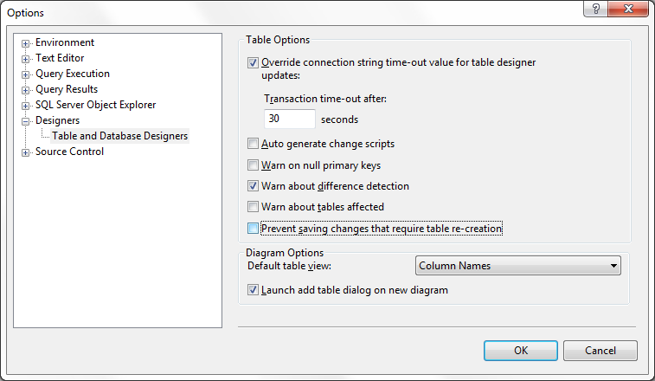

Execution timeout
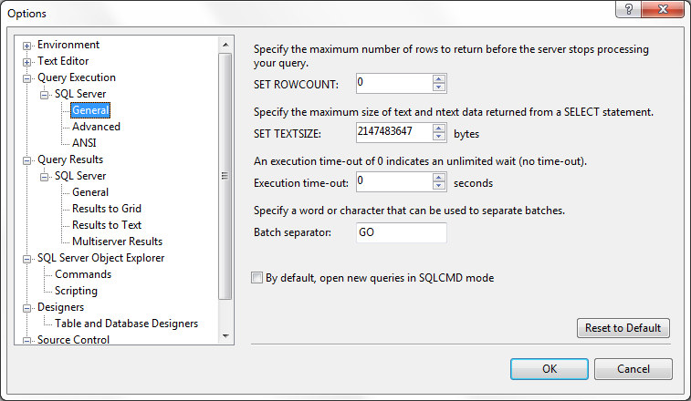

Hierarchical Select
CREATE TABLE #EMPLOYEE (EMPL_ID INT, NAME VARCHAR(100) ,MGR_ID INT)

INSERT INTO #EMPLOYEE VALUES (1, 'Emp1' ,NULL)
INSERT INTO #EMPLOYEE VALUES (2, 'Emp2' ,1)
INSERT INTO #EMPLOYEE VALUES (3, 'Emp3' ,1)
INSERT INTO #EMPLOYEE VALUES (4, 'Emp4' ,2)
INSERT INTO #EMPLOYEE VALUES (5, 'Emp5' ,4)
INSERT INTO #EMPLOYEE VALUES (6, 'Emp6' ,3)

--/*
-- Select from Parent --> Child
;WITH TreeData --(EMPL_ID, MGR_ID, Level)
AS (
SELECT EMPL_ID, NAME, MGR_ID, 0 as Level
FROM #EMPLOYEE
WHERE MGR_ID IS NULL

UNION ALL
SELECT child.EMPL_ID, child.NAME, child.MGR_ID, Level + 1 as Level
FROM #EMPLOYEE child
JOIN TreeData t ON child.MGR_ID = t.EMPL_ID
)
--*/
/*
-- Select from Child --> Parent
;WITH TreeData
AS (
SELECT EMPL_ID, NAME, MGR_ID, 0 as Level
FROM #EMPLOYEE
WHERE EMPL_ID = 6

UNION ALL
SELECT parent.EMPL_ID, parent.NAME, parent.MGR_ID, Level + 1 as Level
FROM #EMPLOYEE parent
JOIN TreeData t ON parent.EMPL_ID = t.MGR_ID
)
*/
SELECT td.EMPL_ID, td.NAME, td.MGR_ID, emp.NAME as manager_name, td.level as Level
FROM TreeData td left join #EMPLOYEE emp on td.MGR_ID=emp.EMPL_ID
order by Level
OPTION (MAXRECURSION 32000)

DROP TABLE #EMPLOYEE

DateTime convert
SELECT convert(datetime, 'Oct 23 2012 11:01AM', 100) -- mon dd yyyy hh:mmAM (or PM)

SELECT convert(datetime, 'Oct 23 2012 11:01AM') -- 2012-10-23 11:01:00.000

-- Without century (yy) string date conversion - convert string to datetime

SELECT convert(datetime, 'Oct 23 12 11:01AM', 0) -- mon dd yy hh:mmAM (or PM)

SELECT convert(datetime, 'Oct 23 12 11:01AM') -- 2012-10-23 11:01:00.000

-- Convert string to datetime sql - convert string to date sql - sql dates format

-- T-SQL convert string to datetime - SQL Server convert string to date

SELECT convert(datetime, '10/23/2016', 101) -- mm/dd/yyyy

SELECT convert(datetime, '2016.10.23', 102) -- yyyy.mm.dd

SELECT convert(datetime, '23/10/2016', 103) -- dd/mm/yyyy

SELECT convert(datetime, '23.10.2016', 104) -- dd.mm.yyyy

SELECT convert(datetime, '23-10-2016', 105) -- dd-mm-yyyy

-- mon types are nondeterministic conversions, dependent on language setting

SELECT convert(datetime, '23 OCT 2016', 106) -- dd mon yyyy

SELECT convert(datetime, 'Oct 23, 2016', 107) -- mon dd, yyyy

-- 2016-10-23 00:00:00.000

SELECT convert(datetime, '20:10:44', 108) -- hh:mm:ss

-- 1900-01-01 20:10:44.000

-- mon dd yyyy hh:mm:ss:mmmAM (or PM) - sql time format

SELECT convert(datetime, 'Oct 23 2016 11:02:44:013AM', 109)

-- 2016-10-23 11:02:44.013

SELECT convert(datetime, '10-23-2016', 110) -- mm-dd-yyyy

SELECT convert(datetime, '2016/10/23', 111) -- yyyy/mm/dd

SELECT convert(datetime, '20161023', 112) -- yyyymmdd

-- 2016-10-23 00:00:00.000

SELECT convert(datetime, '23 Oct 2016 11:02:07:577', 113) -- dd mon yyyy hh:mm:ss:mmm

-- 2016-10-23 11:02:07.577

SELECT convert(datetime, '20:10:25:300', 114) -- hh:mm:ss:mmm(24h)

-- 1900-01-01 20:10:25.300

SELECT convert(datetime, '2016-10-23 20:44:11', 120) -- yyyy-mm-dd hh:mm:ss(24h)

-- 2016-10-23 20:44:11.000

SELECT convert(datetime, '2016-10-23 20:44:11.500', 121) -- yyyy-mm-dd hh:mm:ss.mmm

-- 2016-10-23 20:44:11.500

SELECT convert(datetime, '2008-10-23T18:52:47.513', 126) -- yyyy-mm-ddThh:mm:ss.mmm

-- 2008-10-23 18:52:47.513

-- Convert DDMMYYYY format to datetime

SELECT convert(datetime, STUFF(STUFF('31012016',3,0,'-'),6,0,'-'), 105)

-- 2016-01-31 00:00:00.000

-- SQL string to datetime conversion without century - some exceptions

SELECT convert(datetime, '10/23/16', 1) -- mm/dd/yy

SELECT convert(datetime, '16.10.23', 2) -- yy.mm.dd

SELECT convert(datetime, '23/10/16', 3) -- dd/mm/yy

SELECT convert(datetime, '23.10.16', 4) -- dd.mm.yy

SELECT convert(datetime, '23-10-16', 5) -- dd-mm-yy

SELECT convert(datetime, '23 OCT 16', 6) -- dd mon yy

SELECT convert(datetime, 'Oct 23, 16', 7) -- mon dd, yy

SELECT convert(datetime, '20:10:44', 8) -- hh:mm:ss

SELECT convert(datetime, 'Oct 23 16 11:02:44:013AM', 9)

SELECT convert(datetime, '10-23-16', 10) -- mm-dd-yy

SELECT convert(datetime, '16/10/23', 11) -- yy/mm/dd

SELECT convert(datetime, '161023', 12) -- yymmdd

SELECT convert(datetime, '23 Oct 16 11:02:07:577', 13) -- dd mon yy hh:mm:ss:mmm

SELECT convert(datetime, '20:10:25:300', 14) -- hh:mm:ss:mmm(24h)

SELECT convert(datetime, '2016-10-23 20:44:11',20) -- yyyy-mm-dd hh:mm:ss(24h)

SELECT convert(datetime, '2016-10-23 20:44:11.500', 21) -- yyyy-mm-dd hh:mm:ss.mmm

Backup DB
IF EXISTS (SELECT * FROM sys.objects WHERE type = 'P' AND name = 'SP_BackupDB')
DROP PROCEDURE SP_BackupDB
GO

CREATE PROCEDURE SP_BackupDB
@databaseName sysname, @backupType CHAR(1), @deviceName CHAR(255)
AS
BEGIN
SET NOCOUNT ON;

DECLARE @sqlCommand NVARCHAR(1000)
DECLARE @backupName NVARCHAR(255)
DECLARE @options NVARCHAR(255)

IF @backupType = 'F'
SET @options = ' With Name = '''+ @databaseName +'_Full_Backup'''
IF @backupType = 'D'
SET @options = ' With Name = ''' + @databaseName + '_Diff_Backup''' + ', DIFFERENTIAL'

SET @sqlCommand = 'BACKUP DATABASE ' + @databaseName + ' TO ' + @deviceName + @options
EXECUTE sp_executesql @sqlCommand
END

Change DB Owner
sp_changedbowner @loginame = 'sa'

Features / Functions

Concatenation

Oracle
SELECT CONCAT(id, name, work_date) FROM employee_tbl;

Random String

MS SQL
select SUBSTRING((CONVERT(varchar(255), newid())), 0, 8) as ID from PER_PERIMETRE

Get returned Id when Inserting

MS SQL
INSERT INTO Organization (name) OUTPUT Inserted.ID VALUES('Root');
Or
INSERT INTO Organization (name) VALUES('Root')
SELECT SCOPE_IDENTITY();

Get Current Date

MySQL

MSSQL
GETDATE()

Oracle

Regular Expression

Java
References:
http://www.tutorialspoint.com/java/java_regular_expressions.htm

^(?i)((?!((-deleted))\\d*$)[a-zA-Z0-9._-])+$

Start with one or more alphanumeric, but not end with a word “-deleted” + {a number}

Note: (?i) = Case insensitive
With Javascript: /((?!(-deleted)\d*$)[a-zA-Z0-9])+/
Javascript
var emailPattern = /^[_A-Za-z0-9-]+(\.[_A-Za-z0-9-]+)*@[A-Za-z0-9-]+(\.[A-Za-z0-9-]+)*((\.[A-Za-z]{2,}){1}$)/;

Java Back-reference
http://www.regular-expressions.info/brackets.html

Beyond Compare

Ignore Timestamps
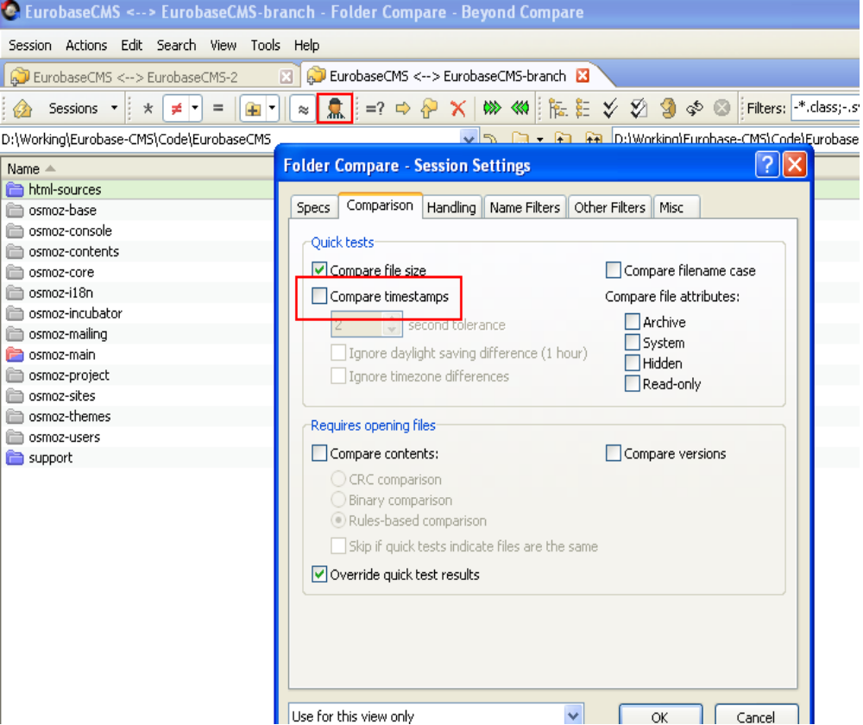

MS Office

Updating Table of Contents
- Select TOC
- Press F9

Total page
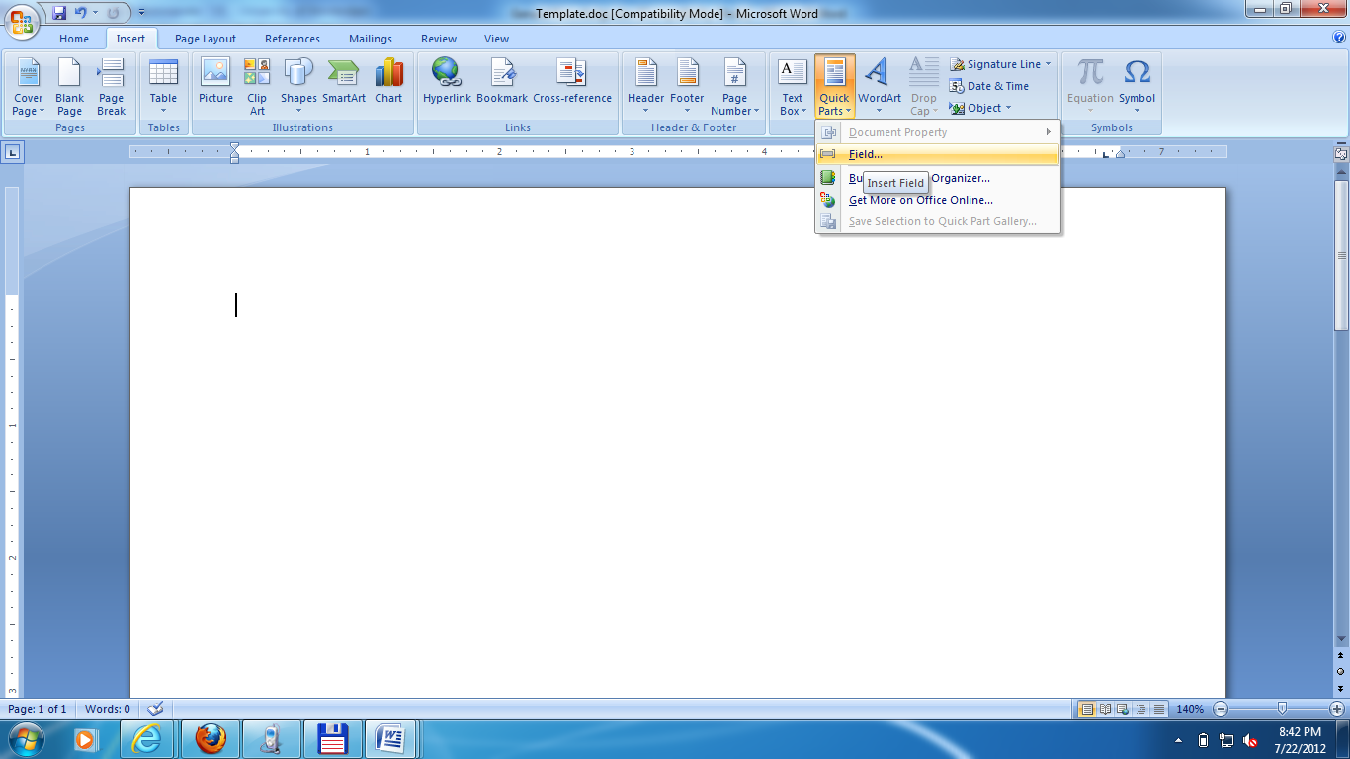

Password protect
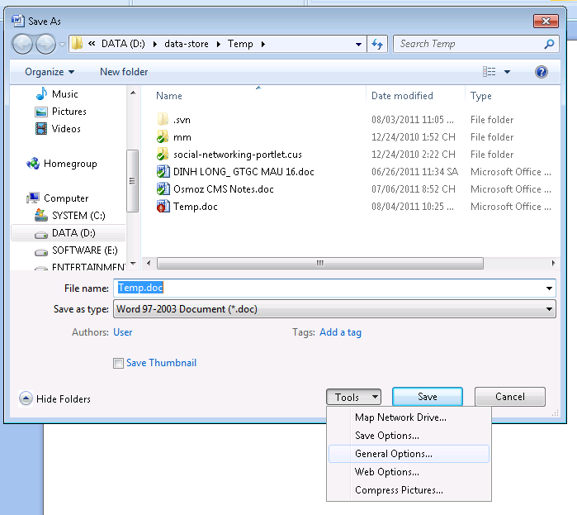

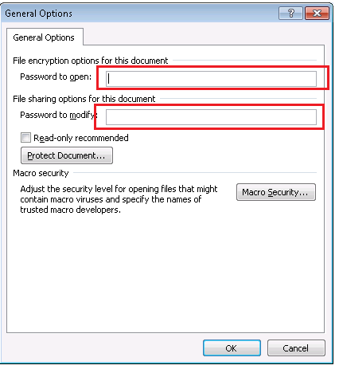

Hide number 0
Chọn các ô có số 0 cần giấu. Nhấn menu Format>Cells (hoặc nhấn Ctrl+1), chọn thẻ Number.
- Trong hộp Category, chọn Custom. Trong hộp Type, gõ 0;-0;;@

Converting PowerPoint to Word

2003
Choose File > Send to > Microsoft Word

2007
Click on the Office button > Publish > Create Handouts in Microsoft Word

2010
Select File > Save & Send > Create Handouts > Create Handouts

Special characters in Excel

New line
=CHAR(10)
Ex:
=”A” & CHAR(10) & “B”
(Remember to format cell to “Wrap text”)

Currency characters
¢ | ALT+0162
£ | ALT+0163
¥ | ALT+0165
 | ALT+0128

Replace 2 new lines with 1 new line
(<shift> 6 key + p)
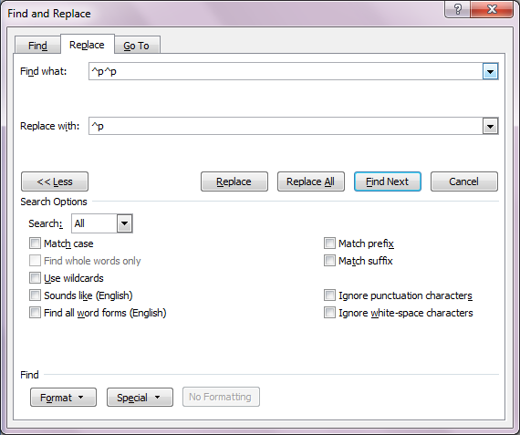

Open Office

Updating Table of Contents
- Right click on Table of Contents
- Select “Update Index /Table”

Password protect
File → Save As → Save with password

Tapestry5

Form Event handling
EventConstants.PREPARE_FOR_SUBMIT, EventConstants.PREPARE, EventConstants.VALIDATE_FORM, EventConstants.SUCCESS (EventConstants.FAILURE), EventConstants.SUBMIT

Validate
The following validators come with the current distribution of Tapestry 5:
Required—checks if the value of the validated component is not null or an empty string.
MinLength—checks if the string (the value of the validated component) is not shorter than the specified length. You will see how to pass the length parameter to this validator shortly.
MaxLength—same as above, but checks if the string is not too long.
Min—ensures that the numeric value of the validated component is not less than the specified value, passed to the validator as a parameter.
Max—as above, but ensures that the value does not exceed the specified limit.
Regexp—checks if the string value fits the specified pattern.

Rules:
The first key checked is formId-fieldId-validatorName-message.
formId: the local component id of the Form component
fieldId: the local component id of the field (TextField, etc.)
validatorName: the name of the validator, i.e., "required" or "minlength"
If there is not message for that key, a second check is made, for fieldId-validatorName-message.
If that does not match a message, then the built-in default validation message is used.

Ex:
* Regexp
<input type="text" t:type="textfield" t:id="email" t:validate="regexp"/>

In the message catalog, let's add the following line to the app.properties file:
Validation rule : email-regexp=^([a-zA-Z0-9_.-])+@(([a-zA-Z0-9-])+.)+([a-zA-Z0-9]{2,4})+$
Validation message: email-regexp-message=Message is shown

Debug
Tapestry.Logging.debug("message");

Hibernate

@AttributeOverride
Ex1:
@Entity
@AttributeOverride( name="externalId", column=@Column(name="column_name“, nullable=false, length=50) )
public class OrderUpdate extends WorkOrderUpdate {
}

Ex2:
@Embedded
@AttributeOverrides( { @AttributeOverride(name = "addNumber", column = @Column(name = "temp_addNumber")),@AttributeOverride(name = "street", column = @Column(name = "temp_street")),@AttributeOverride(name = "district", column = @Column(name = "temp_district")), @AttributeOverride(name = "province", column = @Column(name = "temp_province")) })
public Address getTempAddress() {
return tempAddress;
}

SQL statements order
The SQL statements are issued in the following order
1. all entity insertions in the same order the corresponding objects were saved using Session.save()
2. all entity updates
3. all collection deletions
4. all collection element deletions, updates and insertions
5. all collection insertions
6. all entity deletions in the same order the corresponding objects were deleted using Session.delete()

JQuery

Get Option label
$("#myselectId option:selected").text();

Use CallBack function
//...
getUrlStatus('getStatus.jsp, function(status) {
alert(status);
});

function getUrlStatus(url, callback) {
$.ajax({
url: url,
complete: function(xhr) {
callback(xhr.status);
}
});
}
Show / Hide element
$(document).ready(function() {
// we'll put our code here
$('h1').hide();
$('#Id').hide();
});
Handling Click Events
var DELAY = 250, clicks = 0, timer = null;
function handleClickEvent() {
if (timer == null) {
timer = setTimeout(function() {
clicks = 0;
timer = null;
// single click code
singleClick();
}, DELAY);
}

if(clicks === 1) {
clearTimeout(timer);
timer = null;
clicks = -1;
// double click code
doubleClick()
}
clicks++;
}
Get Selected Option label
$('#ComboBox24 option:selected').text()
$('#ComboBox24 option:selected').html()
Disable/Enable control
$("input[type=submit]").attr("disabled", "disabled");
$("input[type=submit]").removeAttr("disabled");n
Loop over table cells
columns = [2];
var rows = $("#Table1 tr:gt(0)"); // skip the header row
//var rows = $("#" + tableName + " tr:gt(0)");
rows.each(function(index, row) {
$(row).children("td").each(function(columnIndex) {
if(columns.indexOf(columnIndex) >= 0) {
alert($(this).text());
if(!isNaN($(this).text())) {
$(this).text(Number($(this).text()).toFixed(2));
}
}
});
});

Key Codes
Enter: 13

GWT

Create GWT Web project
webAppCreator.cmd -out c:\gwt-app-01 -maven org.java.demo.GwtTest01

Notepad++

Yahoo

Sua loi khong dang nhap duoc
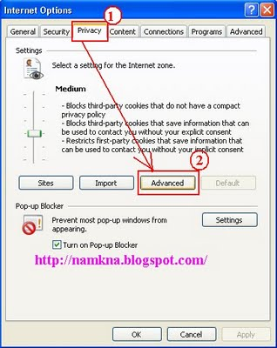

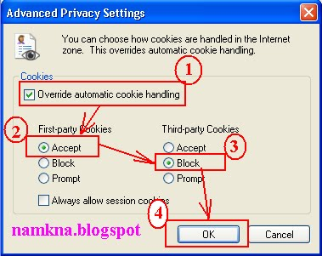

Sample codes

Java

Paging calculation
int totalItems = 1;
int itemPerPage = 4;
int numOfPage = (int)Math.ceil(totalItems * 1.0 / itemPerPage);

Show items by row
List<Integer> l = new ArrayList<Integer>();
for (int i = 1; i < 24; i++) {
l.add(i);
}

int itemPerRow = 4;
for (int i = 0; i < l.size(); i++) {
int columnIndex = i % itemPerRow;
int rowIndex = (int) Math.ceil(i * 1.0 / itemPerRow);
System.out.print(l.get(i) + "(" + columnIndex + ")" + "\t");
if (columnIndex == (itemPerRow - 1)) {
System.out.println();
}
}

Show items by row 2
List list = new ArrayList();
for( int i = 0 ; i < 9 ; i++ ) {
list.add(i);
}

int itemPerRow = 4;
double totalItems = list.size();
int numOfRow = (int)Math.ceil(totalItems * 1.0 / itemPerRow);

outerFor:
for( int i = 0 ; i < numOfRow ; i++ ) {
for( int j = 0 ; j < itemPerRow ; j++ ) {
int index = i * itemPerRow + j;
if(index > list.size() - 1) {
break outerFor;
}

System.out.println(list.get(index));
}
}

isNumeric
public static boolean isNumeric(String str) {
return str != null && str.matches("^(0|[1-9]\\d*)(\\.\\d+)?$");
}

isInteger
public static boolean isInteger(String str) {
return str != null && str.matches("^(0|[1-9]\\d*)$");
}

JavaScript

Get Query Variable
function getQueryVariable(query, variable) {
var vars = query.split("&");
for (var i=0;i<vars.length;i++) {
var pair = vars[i].split("=");
if (pair[0] == variable) {
return pair[1];
}
}
return "";
}

Others

Print large pages

Acrobat Reader
- File → Print
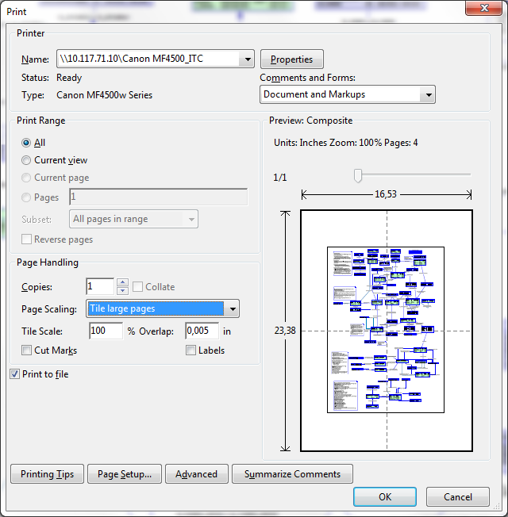

MS Paint
- Print → Page Setup
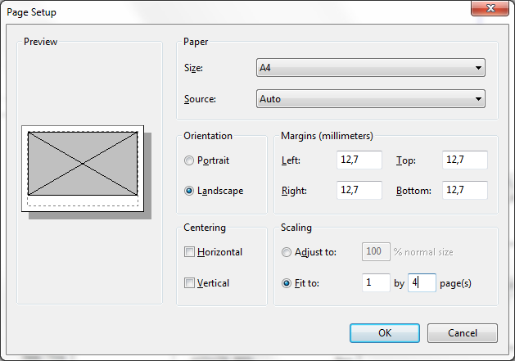

Hibernate/ JPQL functions

Hibernate

Substring
hql = "select substring (oldSid, 5, 2) + '-' + substring (oldSid, 7,6) as newSid from Table";

JPQL (JPA Query)
As well as supporting direct field and relation comparisons, JPQL supports a pre-defined set of functions that you can apply.

CONCAT(string1, string2)
Concatenates two string fields or literals. For example:
SELECT x FROM Magazine x WHERE CONCAT(x.title, 's') = 'JDJs'

SUBSTRING(string, startIndex, length)
Returns the part of the string argument starting at startIndex (1-based) and ending at length characters past startIndex.

SELECT x FROM Magazine x WHERE SUBSTRING(x.title, 1, 1) = 'J'

TRIM([LEADING | TRAILING | BOTH] [character FROM] string
Trims the specified character from either the beginning (LEADING), the ending (TRAILING), or both (BOTH) the beginning and ending of the string argument. If no trim character is specified, the space character will be trimmed.
SELECT x FROM Magazine x WHERE TRIM(BOTH 'J' FROM x.title) = 'D'

LOWER(string)
Returns the lower-case of the specified string argument.

SELECT x FROM Magazine x WHERE LOWER(x.title) = 'jdj'

UPPER(string)
Returns the upper-case of the specified string argument.
SELECT x FROM Magazine x WHERE UPPER(x.title) = 'JAVAPRO'

LENGTH(string)
Returns the number of characters in the specified string argument.
SELECT x FROM Magazine x WHERE LENGTH(x.title) = 3

LOCATE(searchString, candidateString [, startIndex])
Returns the first index of searchString in candidateString. Positions are 1-based. If the string is not found, returns 0.
SELECT x FROM Magazine x WHERE LOCATE('D', x.title) = 2

ABS(number)
Returns the absolute value of the argument.
SELECT x FROM Magazine x WHERE ABS(x.price) >= 5.00

SQRT(number)
Returns the square root of the argument.
SELECT x FROM Magazine x WHERE SQRT(x.price) >= 1.00

MOD(number, divisor)
Returns the modulo of number and divisor.
SELECT x FROM Magazine x WHERE MOD(x.price, 10) = 0

CURRENT_DATE
Returns the current date.

CURRENT_TIME
Returns the current time.

CURRENT_TIMESTAMP
Returns the current timestamp.

Browser

IE

Firefox

URL in new tab
- Type about:config in the address bar
- search for "browser.newtab.url"
- value : about:newtab > double click change

CSS

Selector
http://www.w3schools.com/cssref/css_selectors.asp

